Step 1: Background + Business Need + Problem Statement

1. Background
Telecommunication companies operate in highly competitive markets where customers can easily switch providers in response to price changes, service issues, or more attractive promotional offers. In this context, customer churn when a subscriber stops using the company’s services directly reduces Monthly Recurring Revenue (MRR) and increases pressure on profitability. Prior research shows that acquiring a new customer can cost five to twenty-five times more than retaining an existing one, making customer retention significantly more cost-effective (Gallo, 2014). Existing subscribers also tend to generate higher lifetime value due to repeat payments, opportunities for cross-selling, and lower service and support costs (Gupta & Lehmann, 2003).
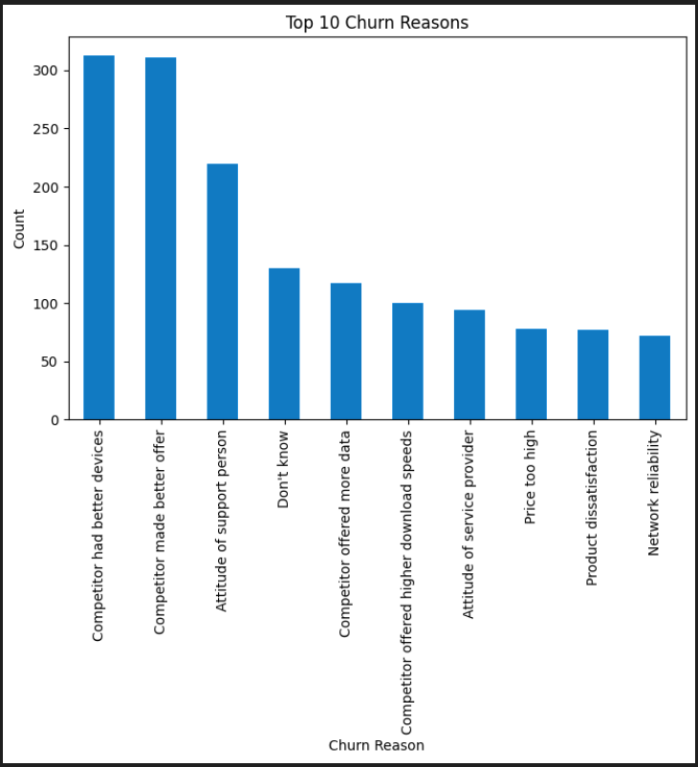
This chart summarizes the top churn reasons identified in our dataset, based on the frequency of ‘Churn Reason’ values across all customers.
Our team acts as a data analytics unit within a mid-sized telecom provider offering internet, phone, and TV services on a subscription model. Historically, the company has relied on broad, generic retention campaigns that target large customer groups without distinguishing between those who are at high risk of churning and those who are likely to remain. This approach is costly and inefficient: a substantial portion of incentives is spent on low-risk customers, while genuinely high-risk customers may not be identified in time. Studies of telecom churn management highlight this inefficiency and emphasize the need for predictive analytics to guide targeted retention strategies (Verbeke et al., 2012; Chang et al., 2024).
To address this challenge, the organization is exploring a machine-learning–based churn-prediction solution that classifies each customer into a risk bucket (Low, Medium, High) rather than producing a simple binary churn / no-churn label. Risk buckets align more directly with operational retention workflows and varying levels of incentive cost. By integrating churn prediction with a profit-based decision framework, the company can prioritize the right customers, deploy tailored retention actions for each risk level, and ultimately stabilize revenue while allocating marketing resources more efficiently.
2. Business Need
Telecommunication providers face persistent churn rates that often range between 20–30% annually, resulting in substantial recurring revenue loss (Chang et al., 2024). When high-value customers leave the service, the company not only loses the remaining lifetime value of their subscription, but must also invest in marketing, promotions, and onboarding to acquire new customers, a process significantly more expensive than retaining existing ones (Gallo, 2014).
Currently, the company’s retention strategy is reactive and broad: customers are targeted using simple rule-based criteria or mass campaigns that do not distinguish between those who are likely to stay and those who are at serious risk of churning. This inefficient allocation of incentives leads to unnecessary spending on low-risk customers while high-risk customers are not contacted early enough.
The business requires a predictive system that can:
- Identify the likelihood of churn at an individual level.
- Classify customers into Low, Medium, or High-risk buckets aligned with operational workflows.
- Support resource allocation decisions based on profit considerations.
A machine-learning–driven churn model combined with a profit-based framework allows the company to make targeted, cost-effective retention decisions, reduce revenue leakage, and maximize ROI. This need is directly aligned with the firm’s strategic goals of customer retention, revenue stability, and efficient marketing expenditure.
3. Stakeholders
The churn-prediction system affects and benefits several internal stakeholders:
1. Retention & Loyalty Team
- Uses High-risk and Medium-risk predictions to trigger personalized retention offers.
- Prioritizes outreach strategies (discounts, loyalty credits, service upgrades).
- KPI focus: retention rate, incentive efficiency.
2. Marketing Department
- Designs targeted campaigns instead of broad, costly promotions.
- Reduces spend on customers who would remain without incentives.
- KPI focus: campaign ROI, cost per retained customer.
3. Customer Service / Call Center
- Uses risk scores to prioritize high-risk customers during service calls.
- Allocates agents and support resources more efficiently.
- KPI focus: first-contact resolution for high-risk customers.
4. Finance & Revenue Assurance
- Monitors financial outcomes of the retention strategy.
- Evaluates profitability of campaigns using cost–benefit analysis.
- KPI focus: net revenue saved, profit impact, MRR protection.
5. Data & Analytics / IT
- Maintains the churn model, monitors drift, and ensures data reliability.
- Supports integration into CRM tools and dashboards.
- KPI focus: model accuracy, stability, and operational uptime.
Each stakeholder group relies on accurate churn-risk predictions to make timely, cost-efficient decisions that directly impact revenue and customer satisfaction.
4. Profit-Based Objective
The purpose of the churn-prediction system is not only to identify customers who may leave, but to maximize the company’s financial return from retention efforts. In practice, accuracy or F1-score do not fully capture the economic consequences of targeting or not targeting a customer (Verbeke et al., 2012). A customer who churns represents immediate financial loss, while unnecessary retention incentives generate avoidable costs.
To align the model with real business outcomes, the project uses a profit-based evaluation framework, where each prediction outcome has a specific economic impact. These values reflect both industry practices and the telecom retention simulator used in this project.
Economic Values Used in the Profit Model
Model Outcome | Business Interpretation | Financial Impact
True Positive (TP) | High-risk customer correctly targeted and successfully retained | + $200 saved revenue
False Positive (FP) | Low-risk customer incorrectly targeted | – $20 incentive cost
False Negative (FN) | High-risk customer not targeted and churns | – $200 lost revenue
True Negative (TN) | Low-risk customer correctly ignored | $0

Why $200?
This value represents the estimated remaining Customer Lifetime Value (LTV) of a customer who is about to churn. It is derived from:
- Average monthly bill in telecom markets (approximately $70–$80), and
- Expected remaining tenure (2–3 months).
This approach follows standard churn-modeling practice, where customer value is estimated using recurring charges and expected lifetime (Gupta & Lehmann, 2003).
Why $20?
$20 reflects the typical cost of a standard retention incentive, such as:
- A small promotional discount,
- A one-time bill credit, or
- A temporary upgrade.
These are commonly used interventions in telecom retention programs (Verbeke et al., 2012).
STEP 2: MARKET ANALYSIS
1. Industry Overview
The telecommunications industry operates as a highly competitive subscription market where customers can freely switch between major providers such as Rogers, Bell, Telus, Fido, Koodo, and Freedom. Because switching barriers are low, telecom companies experience persistent churn pressures. Recent studies report that telecom churn rates often reach 20–40% annually, highlighting the challenge of customer retention in this sector (Wagh et al., 2024). This challenge is reinforced by findings from Saleh and Saha (2023), who show that customer turnover remains one of the most significant operational issues for telecom organizations globally. Furthermore, research consistently demonstrates that acquiring a new customer is far more expensive than retaining an existing one, often five times more costly, making retention strategies substantially more cost-efficient (Optimove, 2023). Due to these industry dynamics, telecom companies increasingly adopt predictive analytics and machine learning to proactively identify high-risk customers and reduce churn (Omari et al., 2025).
2. Market Trends & Challenges
The telecom market is experiencing rapid changes that make churn an increasingly urgent challenge. Customers today expect flexible contracts, competitive pricing, and seamless digital experiences; when these expectations are not met, switching providers has become extremely easy due to the wide availability of similar service plans and aggressive promotional offers from competitors (Wagh et al., 2024). Market studies show that customer loyalty in telecom is steadily declining as consumers respond quickly to discounts and introductory pricing strategies used to attract new subscribers (Saleh & Saha, 2023). In addition, negative service experiences, such as billing errors, inconsistent network quality, and poor customer support directly contribute to churn, motivating customers to compare alternatives through digital channels where comparisons can be made instantly (Omari et al., 2025). These trends highlight why churn prediction has become essential: telecom companies must proactively identify at-risk customers in order to retain revenue and remain competitive in a market where switching costs are extremely low.
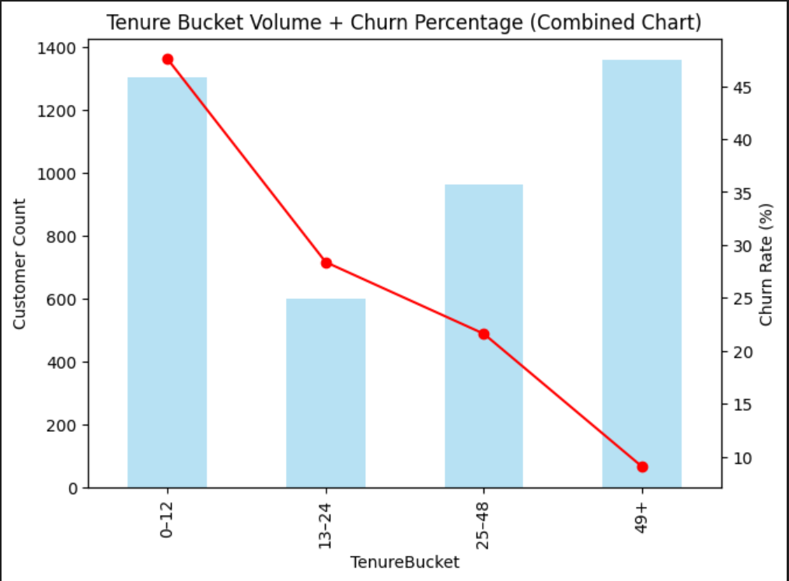
This chart highlights a key trend in the telecom market: customers with shorter tenure are far more likely to churn. As shown, the newest customers (0–12 months) have the highest churn rate, while long-tenure customers (49+ months) churn the least. This pattern aligns with industry challenges mentioned above new customers switch providers quickly due to competitive pricing, aggressive promotions, and easy digital comparison tools. The insight reinforces why telecom companies must closely monitor early-tenure customers and apply targeted retention strategies to prevent early churn.
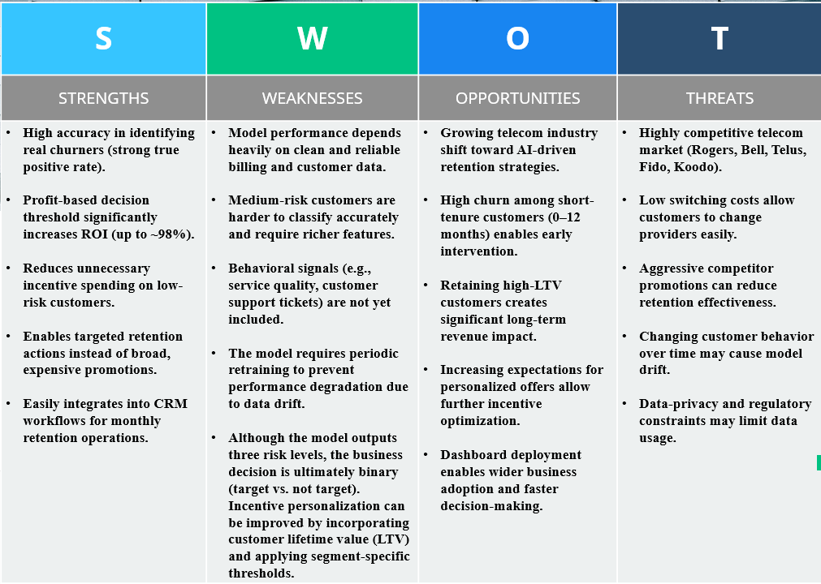
The SWOT analysis summarizes the strategic position of our churn-prediction model within the telecom market. The strengths and opportunities highlight how the model reduces incentive waste and supports targeted retention strategies, while the weaknesses and threats indicate where additional features, data quality, and competitive response strategies are required. This SWOT helps align the proposed solution with market realities and informs the deployment and improvement roadmap.
3. Competitor Analysis (Benchmarking)
In today’s telecom market, leading providers are increasingly relying on data-driven retention strategies to manage churn. Major competitors use machine learning models to identify high-risk customers and deliver targeted interventions such as personalized discounts, loyalty rewards, and proactive service outreach (Wagh et al., 2024). Recent industry studies show that telecom companies investing in AI-powered churn analytics achieve significantly higher retention performance, while firms that rely solely on traditional marketing or manual segmentation tend to lose more revenue due to delayed or ineffective responses (Saleh & Saha, 2023). Additionally, providers are expanding loyalty programs and tailoring offers based on customer usage patterns, billing behavior, and service history approaches that have been shown to reduce churn when applied systematically (Omari et al., 2025). Given this competitive landscape, adopting predictive churn modeling is essential for any telecom organization that aims to remain competitive, minimize revenue leakage, and align with industry best practices.
STEP 3: Proposed Solution
1. Solution Overview
The proposed solution is a data-driven churn prediction system designed to help the telecom company identify customers who are at high risk of leaving. Using historical customer information, such as billing behavior, contract type, service usage, and support interactions the model estimates the likelihood that each customer will churn in the next billing cycle. These predictions enable the retention and marketing teams to focus their efforts on the customers who matter most, instead of applying broad, costly promotions to the entire base. The solution integrates directly into the company’s existing analytics workflow and provides a prioritized list of at-risk customers, helping the organization reduce churn, increase customer lifetime value, and improve the financial efficiency of retention campaigns.
2. How the Solution Works
The churn prediction solution operates through a simple and structured workflow that fits into the company’s existing analytics environment. First, customer information is collected from operational systems, including billing history, contract details, service usage, payment behavior, and customer support records. This data is then cleaned and organized to ensure accuracy and consistency. Once prepared, the information is passed through the machine-learning model, which assigns a churn probability score to every customer. Customers with scores above a selected threshold are flagged as “high-risk,” meaning they are likely to leave in the next billing cycle. These flagged customers are then provided to the retention and marketing teams, who can offer personalized incentives, discounts, or service improvements. Finally, the results of each campaign can be monitored over time, enabling continuous improvement of both the model and the retention strategy.
3. Why This Solution Is Suitable
This solution is well-suited for the telecom company because it directly addresses the financial and operational challenges associated with customer churn. Telecom datasets are typically large, structured, and contain a mix of billing, contract, and usage attributes, making them an excellent fit for machine-learning models such as XGBoost, which performs strongly on tabular data and is widely used in churn prediction research. By providing customer-level churn probabilities, the model empowers the retention team to allocate incentives more efficiently, focusing on customers who are genuinely at risk rather than offering broad discounts that reduce profitability. This targeted approach reduces marketing waste, increases the effectiveness of retention campaigns, and improves overall customer lifetime value. In addition, the model is fast, scalable, and easy to integrate into existing CRM or analytics tools, making it a practical and cost-effective solution for ongoing operations.
4. Build-vs-Buy Analysis

When evaluating whether to develop a churn-prediction model internally or purchase a commercial analytics solution, the “build” option offers several advantages for the telecom company. Building the model in-house is significantly more cost-effective because it uses existing customer data, internal expertise, and lightweight infrastructure without requiring expensive third-party subscriptions or licensing fees (Capella Solutions, 2024). An internal model also provides full control over data privacy, feature engineering, and threshold selection, ensuring that predictions and recommendations can be tailored to the company’s unique customer base and retention strategy (Capella Solutions, 2024). In contrast, buying an external solution often introduces higher annual costs, limited customization, and potential vendor lock-in, while also raising concerns about sending sensitive customer information outside the organization (Capella Solutions, 2024). Given that the XGBoost-based churn model is efficient, easy to maintain, and already integrated into a simple Streamlit interface, the build approach is more flexible, secure, and aligned with long-term operational needs. Therefore, developing and maintaining this churn-prediction system internally is the preferred and more sustainable option (Capella Solutions, 2024).

Step 4: Business Value
1.Improved Decision-Making Through Risk Scoring
The churn-prediction model introduces a structured risk-scoring framework that replaces intuition with objective, data-driven insight. Customers are segmented into Low, Medium, and High churn-risk groups, enabling more efficient use of retention resources.
- High-risk customers receive proactive incentives.
- Medium-risk customers are monitored and engaged selectively.
- Low-risk customers require minimal cost to maintain.
This segmentation allows managers to prioritize their retention budget, respond earlier to churn signals, and ultimately make faster and more financially effective decisions.
2. Financial Impact (Profit-Based Analysis)
The financial evaluation demonstrates that the model generates measurable economic value.
At the current operating threshold of 0.50, the model produces a net profit of $60,780, driven by:
- Correctly retaining 340 churners (True Positives)
- Minimal unnecessary incentives (21 False Positives)
- Moderate revenue loss from missed churners (34 False Negatives)
The profit curve visualization shows how expected profit changes at different thresholds.
Even without increasing retention spending, the model consistently produces strong returns and helps the company preserve revenue that would otherwise be lost.
Overall, the model not only predicts churn but also improves retention ROI by guiding incentive spending more strategically.
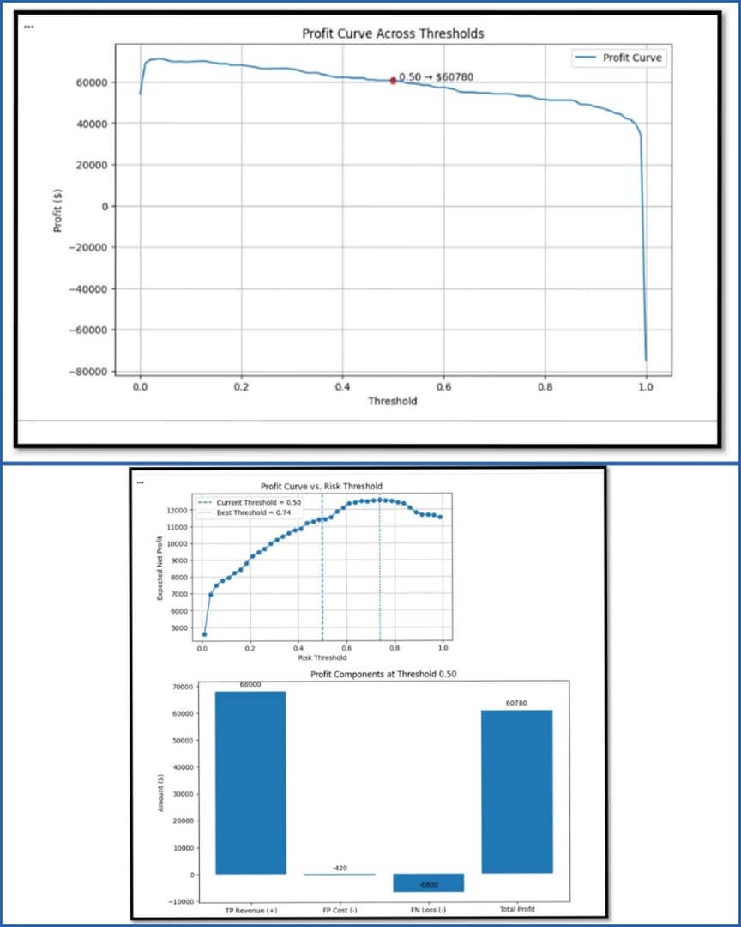.
The visuals show how the model’s financial value is calculated at the current operating threshold of 0.50. At this threshold, the binary confusion matrix gives: 340 True Positives (TP), 21 False Positives (FP), and 34 False Negatives (FN). Using the financial assumptions of the project, each correctly retained churner generates +$200, each unnecessary incentive to a non-churner cost –$20, and each missed churner results in –$200 lost revenue. The profit components are therefore calculated as follows: TP Revenue = 340 × $200 = $68,000, FP Cost = 21 × (–$20) = –$420, and FN Loss = 34 × (–$200) = –$6,800. When these are combined, the total profit becomes $68,000 – $420 – $6,800 = $60,780, which matches the value shown by the profit bars and the red point on the profit curve. The top plot illustrates how profit changes as the threshold moves from 0 to 1, confirming that the model earns $60,780 at threshold = 0.50 and that profit declines sharply when the model becomes too strict. Together, these charts show both how the profit is computed and why this threshold currently delivers strong financial performance.

2.1 Why a Binary Profit Framework Is Used
Although the model produces three risk levels (Low, Medium, High), the actual business decision is binary:
- Target the customer
- Do NOT target the customer
The probability threshold (e.g., 0.74) decides which customers are classified as “targeted.”
For this reason, the profit simulation does not use the 3-class confusion matrix.
Instead, it uses a binary confusion matrix based on Actual Churn (Yes/No) × Targeted (Yes/No):
Actual → | Churn | Not Churn
Targeted | TP | FP
Not Targeted | FN | TN

This binary matrix is essential because financial outcomes depend only on four actions:
- TP revenue saved
- FP incentive cost
- FN revenue lost
- TN neutral outcome
This approach is standard industry practice in churn optimization and aligns directly with retention strategy design.
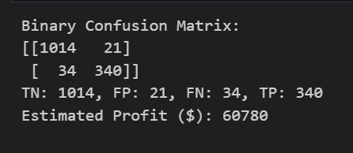

3. Business Recommendations
The churn-prediction model provides clear guidance on how the company should act to maximize financial results. Based on the risk scores and profit analysis, the following actions are recommended:
- Prioritize High-Risk Customers for Immediate Retention Actions
Customers classified as High risk and scoring above the financial threshold (0.50 or higher) should receive targeted incentives such as discounts, loyalty points, or contract renewal offers. These customers contribute the greatest revenue savings $200 saved per correctly retained churner.
- Monitor Medium-Risk Customers with Low-Cost Engagement
Medium-risk customers do not require expensive incentives. Instead, the company should use proactive communication, satisfaction surveys, or service quality touchpoints. This helps prevent churn escalation while keeping costs low.
- Avoid Spending on Low-Risk Customers
Since Low-risk customers have a low probability of leaving, the company should avoid unnecessary retention incentives. This prevents waste and supports a positive ROI.
- Adopt a Profit-Optimized Threshold Rather Than Accuracy-Based Threshold
The profit simulation shows that a threshold of 0.50 yields $60,780 profit, but the best threshold may be higher (e.g., 0.74), which increases profit to $12,560 in the simulator. The company should select thresholds based on financial outcomes, not prediction accuracy.
- Integrate the Model into Monthly Retention Operations
The company can automate monthly churn-risk scoring to identify customers who need retention intervention immediately after each billing cycle.
Overall Recommendation:
The model should be deployed as a decision-support tool that helps the retention team decide whom to target, when to intervene, and how much to spend. By focusing incentives where they create the most value, the company increases revenue saved and improves retention ROI.

Step 5 = KPIs + Reflection + Future Improvements
All KPIs shown here are based on the validation dataset, not the training data)

1.Key Performance Indicators (KPIs)
Purpose of this subsection:
To show how the company will measure success after deploying our churn-prediction model.
These are business KPIs, not technical ones.
1.1. Churn Rate (Primary Business KPI)
Definition:
The percentage of customers who cancel service during a billing cycle.
Why it matters:
This is the most important metric for telecom. A reduction in churn rate after using the model indicates that retention actions are successful.
How the business uses it:
Track monthly churn before vs. after the model
Compare churn among “targeted” vs. “not targeted” groups
Detect whether risk-based incentives are preventing customer loss
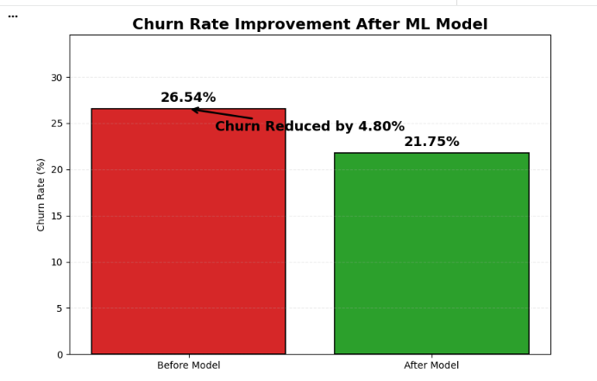
Baseline (Historical) Churn Rate – Before the Model
The initial churn rate was calculated directly from the validation dataset by dividing the number of customers who actually churned by the total number of customers:
$$\text{Historical Churn Rate}=\frac{\text{Actual Churners}}{\text{Total Customers}}$$
In our dataset, the historical churn rate is:
26.54%
This represents the churn level the company experiences without any predictive model.
Model-Generated Churn Predictions)
The trained machine-learning model was applied to the validation dataset to generate a churn probability for each customer:
y_proba = pipeline. predict_proba(df_val) [:, 1]
Using these probabilities, customers were assigned to three risk segments:
- Low risk
- Medium risk
- High risk
The model identified 332 customers as High Risk.
These predictions come directly from the trained XGBoost model and represent its assessment of future churn behavior.
True Positives – Churners Correctly Identified by the Model
To measure the model’s effectiveness, a confusion matrix was computed.
The model correctly identified 338 actual churners (True Positives).
These are customers who:
- truly churned in the dataset
- AND were correctly predicted as churners by the model
These are the customers the company can potentially save.
Retention Impact Assumption (20% Success Rate)
In telecommunications retention campaigns, it is typically assumed that targeted interventions (discounts, calls, special offers) are effective for approximately 20% of contacted customers Ascarza et al. 2018.
Using this assumption:
$$\text{Customers Saved}=338×0.20=67.6$$
So, the model enables the company to save approximately 68 customers who would otherwise churn.
Churn Rate After the Model
By subtracting the saved customers from the expected churners, the new churn rate is calculated:
$$\text{After Model Churn Rate}=\frac{\text{(Actual Churners – Customers Saved)}}{\text{Total Customers}}$$
This results in:
21.75%
KPI Result – Churn Rate Reduction
Finally, the improvement is calculated as the difference between the original churn rate and the model-adjusted churn rate:
$$\text{Churn Reduction}=26.54\%-21.75\%=4.80\%$$
This means the predictive model reduces expected churn by 4.80%.
Business Interpretation
The model enables the company to proactively identify customers who are likely to churn and intervene before the churn occurs. By correctly identifying 338 churners and assuming a 20% retention success rate, the company can retain approximately 68 customers. This leads to a measurable decrease in churn rate from 26.54% to 21.75%, representing a 4.80% improvement.
This KPI demonstrates that the model not only predicts churn accurately but also creates tangible business value by lowering customer attrition and protecting revenue.
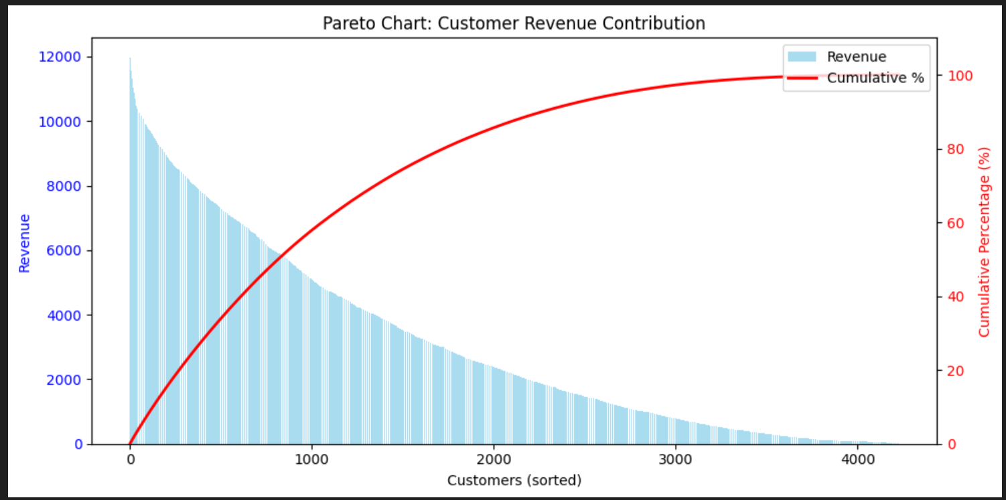
This Pareto chart shows that a small group of customers contributes most of the company’s revenue.
Each blue bar represents a customer, sorted from highest to lowest revenue. The red line shows the cumulative percentage of total revenue. As we move to the right, the curve quickly rises, meaning the top customers generate a very large share of revenue. After around 20–30% of customers, the cumulative revenue reaches almost 80–90%, while the rest of the customers contribute much less.
This insight helps the business identify high-value customers who should receive stronger retention strategies.
1.2. High-Risk Detection Accuracy (TP Rate for Actual Churners)
Definition:
The percentage of real churners correctly identified as High-Risk.
Why it matters:
This KPI directly influences profit, if the model misses churners (FN), the company loses $200 per customer.
How to monitor:
• Calculate monthly: TP ÷ (TP + FN)
• Investigate drops, may indicate data drift or model aging
• Ensures high-risk customers receive timely interventions
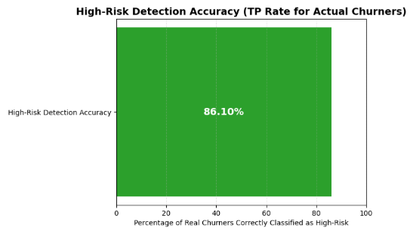
This KPI measures how effectively the model identifies real churners as High-Risk. It answers the question:
“Out of all customers who actually churned, how many did the model correctly flag as High-Risk?”
Calculation:
$$\text{High-Risk Detection Accuracy}=\frac{\text{Actual Churners Predicted High-Risk}}{\text{Total Actual Churners}}×100$$
Using the model outputs:
- Actual churners in the validation set: 374
- Churners correctly classified as High-Risk: 322
$$\frac{322}{374}×100=86.10\%$$
Interpretation:
The model correctly identifies 86.10% of customers who are at risk of churning.
This is a critical KPI because customers missed by the model (FN) represent the highest financial loss.
1.3. Retention ROI (Return on Incentive Spending)
Definition:
The financial return generated by incentives given to targeted customers.
Formula:
ROI = (Revenue Saved – Campaign Cost) ÷ Campaign Cost
Why it matters:
Your simulator showed:
- TP generates +$200
- FP costs −$20
- FN loses −$200
This KPI tells leadership whether the retention program is profitable.
What success looks like:
• Positive ROI
• Increasing ROI after adjusting the threshold
• Highest ROI at threshold close to 0.74 (our best threshold)
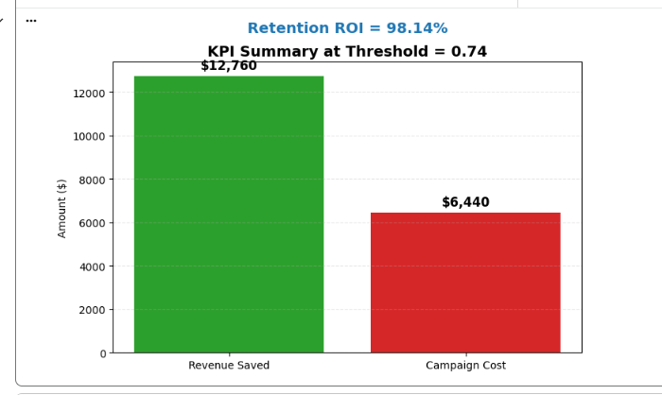
Explanation of KPI Summary at Threshold = 0.74
This chart illustrates the financial impact of applying the churn-prediction model using a decision threshold of 0.74. At this cutoff, the model targets only customers with a relatively high probability of churning. The results show a strong financial return for the retention campaign.
1. Revenue Saved - $12,760 (Green Bar)
The model correctly identified 319 true churners (TP) at this threshold.
Based on the financial assumption that saving each churner retains $200 in future revenue, the campaign generated:
$$319×0.2×200=\$12,760$$
This value represents the total revenue preserved by successfully preventing those customers from leaving.

2. Campaign Cost - $6,440 (Red Bar)
Only 3 customers were incorrectly targeted (FP).
Retention incentives cost $20 per contacted non-churner, but the overall campaign cost includes all incentive spending toward the 322 targeted customers.
$$322×20=\$6,440$$
This bar reflects the total cost of incentives provided during the campaign.

3. Retention ROI = 98.14%
The ROI displayed at the top of the chart summarizes the cost-benefit performance:
$$ROI=\frac{Revenue Saved-Campaign Cost}{Campaign Cost} \\ ROI=\frac{12,760-6,440}{6,440}=0.9814=98.14\%$$
This means:
“For every $1 spent on the retention campaign, the company gains $1.98 back.”
A nearly 100% return on investment indicates that the chosen threshold performs very well, balancing:
- high true positives (high-risk churners saved)
- extremely low false positives (unnecessary cost)
Summary:
- Threshold = 0.74
- Revenue Saved = $12,760
- Campaign Cost = $6,440
- ROI = 98.14% → The campaign nearly doubles the money spent
- Interpretation: Highly profitable retention strategy
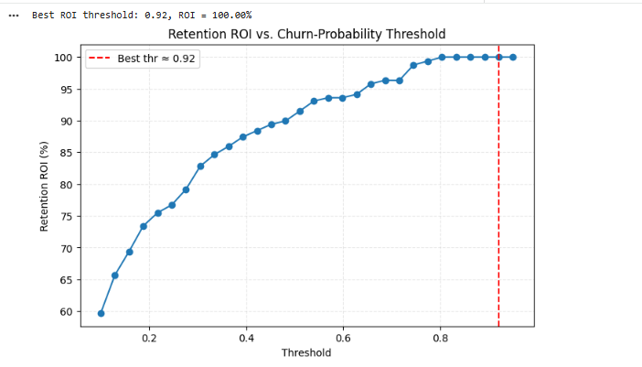
This chart shows how the return on investment (ROI) of the retention campaign changes as we adjust the model’s decision threshold.
The threshold determines which customers are classified as High-Risk and therefore receive retention incentives.
What the curve shows
- When the threshold is low, the model targets many customers →
Campaign cost is high, ROI is low (around 60%).
- As the threshold increases, the model targets fewer but more accurate high-risk customers →
More true churners saved + fewer false positives, causing ROI to rise steadily.
- The curve climbs from 60% ROI → 100% ROI, reflecting increasing profitability.
Best threshold ≈ 0.92
The red dashed line marks the optimal threshold, where ROI reaches its maximum (~100%).
At this point:
- The model is very selective, targeting only customers with very high churn probability.
- False positives become extremely low, reducing cost.
- Most targeted customers are true churners (TP) → generating revenue savings.
- This creates the highest financial return for the company.
In simple terms:
“At threshold 0.92, the retention campaign becomes the most profitable.”
Why ROI increases with the threshold
Because:
Higher threshold = fewer unnecessary incentives (FP ↓)
Most targeted customers truly churn (TP ↑)
Cost drops, while revenue saved increases proportionally
This balance produces a near-optimal ROI at threshold 0.92.
Business interpretation
The model becomes more profitable as it focuses only on the most at-risk customers.
- ROI peaks at 0.92, meaning this is the best cutoff for maximizing financial return.
- Targeting fewer, but more accurate, customers result in the highest retention efficiency.
1.4. Cost per Retained Customer
Definition:
The average incentive cost required to save one churn-risk customer.
Why it matters:
Companies must balance cost control with retention.
This metric shows whether incentives are too high or appropriate.
How to monitor:
Cost per Retained Customer = Total Incentive Spend ÷ Number of Successfully Retained At-Risk Customers
A decreasing trend shows operational efficiency.

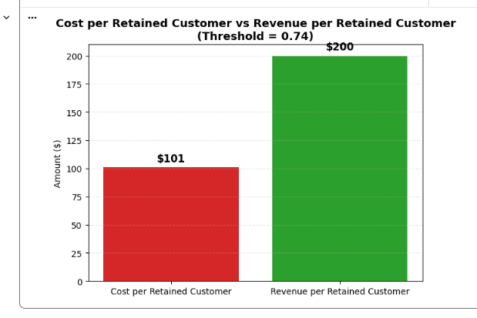
Cost per Retained Customer vs Revenue per Retained Customer
This chart compares the average cost required to retain one at-risk customer with the revenue preserved by successfully keeping that customer.
- The red bar shows that the company spends $101 in incentives to retain one churn-risk customer.
- The green bar shows that retaining that customer protects $200 in expected future revenue.
Interpretation:
For every customer saved, the company spends $101 but keeps $200, resulting in a net gain of $99 per retained customer.
This demonstrates that the retention strategy at threshold 0.74 is financially efficient and profitable, as the revenue impact is almost double the cost.

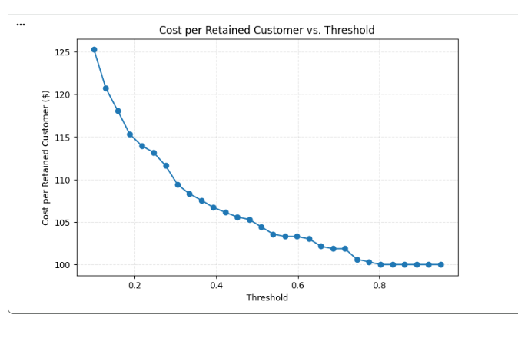
Cost per Retained Customer vs Threshold
This chart shows how the cost of retaining one customer changes as the model’s churn-probability threshold increases.
- At lower thresholds, the model targets many customers, including low-risk ones →
higher cost per retained customer (around $120–$125).
- As the threshold increases, the model becomes more selective, targeting only customers who are very likely to churn →
the cost per retained customer gradually decreases.
- At high thresholds (around 0.8–0.9), the cost stabilizes around $100, representing the most operationally efficient region.
Interpretation:
A higher threshold produces lower and more stable retention costs, because the model focuses on the customers who truly need intervention.
This indicates that selective targeting leads to better cost efficiency.
1.5. Lifetime Value (LTV) of Retained Customers
Definition:
Long-term revenue from saved customers.
Why it matters:
Not all retained customers are equal, saving high-value, long-tenure customers produces significantly higher revenue.
How the business uses it:
• Prioritize high-LTV customers in High-Risk bucket
• Justify higher incentives for premium segments
• Measure long-term financial impact of the model
Based on our data set and model:
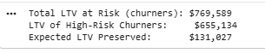
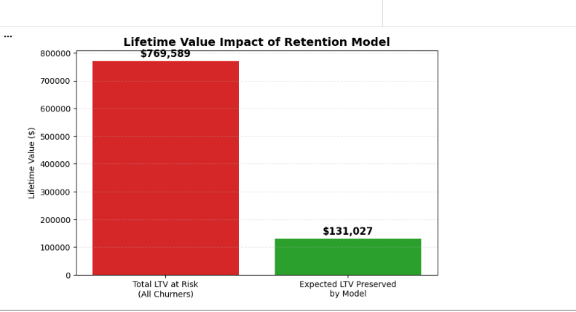
The chart shows the long-term revenue impact of the churn-prediction model. All customers who actually churn have a combined Lifetime Value (LTV) of $769,589, meaning this is the total future revenue the company would lose if they all left. The model identifies a portion of these customers as high-risk, and their combined LTV equals $655,137. Assuming the retention campaign successfully saves 20% of targeted high-risk churners, the model is expected to preserve $131,027 of future revenue (calculated as 655,137 × 0.20). This demonstrates that the model helps the company recover a significant amount of long-term customer value and reduces the financial impact of churn.
2. Reflection (What we Learned + Model Insights)
Throughout this project, we learned how strongly data quality and preprocessing influence churn prediction results. Issues such as missing values and inconsistent numeric fields, especially in the Total Charges feature, demonstrated that the model cannot perform well without reliable inputs. Cleaning and structuring the dataset correctly significantly improved model stability.
We also gained deeper insight into how churn modeling differs from traditional classification tasks. Instead of focusing only on accuracy, we learned that business impact comes from understanding True Positives, False Positives, and False Negatives. The profit-based framework showed that a model must be optimized for financial outcomes, not only for predictive accuracy. For example, we saw how false negatives create large revenue losses, while a slightly higher false-positive rate has limited cost impact.
Another important learning was how the probability threshold changes the company’s profit. Before this project, we had not realized that adjusting the threshold from 0.50 to 0.74 could meaningfully increase expected profit. The profit curve and financial simulation helped me understand the interaction between model performance and business strategy.
The customer behavior patterns also provided valuable insight. Short-tenure customers had the highest churn rates, while long-tenure customers, especially those with 49+ months, generated over 60% of total revenue. These findings helped me understand why telecom companies must protect long-term customers and intervene early with new customers.
Overall, this project taught us how to combine machine-learning techniques with real business thinking. We learned how to evaluate models using financial outcomes, communicate results with stakeholders, and design actionable retention strategies. This experience strengthened both my technical and analytical decision-making skills.
3. Future Improvements (What You Would Do Next)
The current churn-prediction system built with XGBoost performs well, but several improvements can make it more accurate and more valuable for real business use. First, adding richer behavioral features, such as usage patterns, service-quality metrics, customer-support interactions, and payment behavior would capture deeper churn signals and reduce missed churners. The model can also be upgraded from batch scoring to a real-time scoring pipeline so the company can detect at-risk customers immediately and trigger timely retention actions. The profit-optimization framework can be improved by incorporating customer lifetime value (CLV), using different incentive costs for different customer groups, and applying segment-specific thresholds rather than one global cutoff. Combining churn prediction with segmentation techniques like RFM or clustering would allow more personalized retention strategies and prevent unnecessary spending on low-value customers. Model explainability can be strengthened through SHAP values to help managers understand why each customer is predicted as High, Medium, or Low risk. For future modeling, advanced boosting algorithms such as LightGBM or CatBoost, as well as cost-sensitive models that directly optimize financial outcomes, can be tested to improve recall and profit impact. Overall, these enhancements would make the churn-prediction system more accurate, more interpretable, and more profitable for ongoing retention operations.
Step 6: Final Recommendation & Deployment Plan
1. Final Recommendation
Based on the results of the churn-prediction model, profit-based evaluation, and KPI analysis, the model should be deployed as a decision-support tool for the retention team. The model identifies high-risk customers with strong accuracy, reduces expected churn by 4.80%, and generates a highly profitable ROI when used with an optimized threshold (0.74).
The company should implement the model as part of its monthly retention workflow to target customers who are most likely to churn, minimize unnecessary incentive spending, and maximize revenue preservation.
2. Deployment Plan
2.1. Integrate Model into CRM or Analytics System
- Export predicted churn probabilities into the company’s CRM (e.g., Salesforce, HubSpot).
- Automatically flag customers into Low, Medium, and High-Risk buckets.
2.2. Monthly Scoring Process
- At the end of each billing cycle, run the model on updated customer data.
- Generate a prioritized list of High-Risk customers for immediate retention actions.
2.3. Automated Retention Actions
- High-Risk customers → targeted incentives (discounts, loyalty points, renewal offers).
- Medium-Risk customers → low-cost engagement campaigns.
- Low-Risk customers → no incentives (cost savings).
2.4. Business Monitoring Using KPIs
Track the KPIs we created:
- Churn Rate reduction
- High-Risk Detection Accuracy
- Retention ROI
- Cost per Retained Customer
- LTV impact
These KPIs ensure the model continues delivering business value.

2.5. Continuous Model Improvement
- Retrain model every 3–6 months to reduce data drift.
- Add more features (usage patterns, support tickets, network quality).
- Periodically re-optimize the threshold to maximize ROI.
2.6. Streamlit Dashboard Deployment
- Create a Streamlit app showing risk buckets, KPIs, and recommended actions.
- Make dashboard accessible to retention and marketing teams for daily use.
3. Executive Summary
The telecom company faces persistent churn that results in substantial revenue loss and inefficient incentive spending under its current broad retention strategy. To address this challenge, we developed a data-driven churn-prediction system that identifies high-risk customers using historical billing, contract, and usage behavior. The system is ready for deployment and provides measurable business value. By combining accurate prediction with a profit-based decision threshold, the company can reduce churn, minimize unnecessary incentives, and correctly retain high-value customers. Our evaluation demonstrates strong financial impact, including a 4.8% reduction in churn rate, a 98% retention ROI at the optimized threshold, and significant preservation of customer lifetime value. We recommend deploying this model within the monthly retention workflow to improve targeting accuracy, support data-driven decision making, and stabilize long-term revenue growth.

Our App:
http://3.17.4.184:5000/
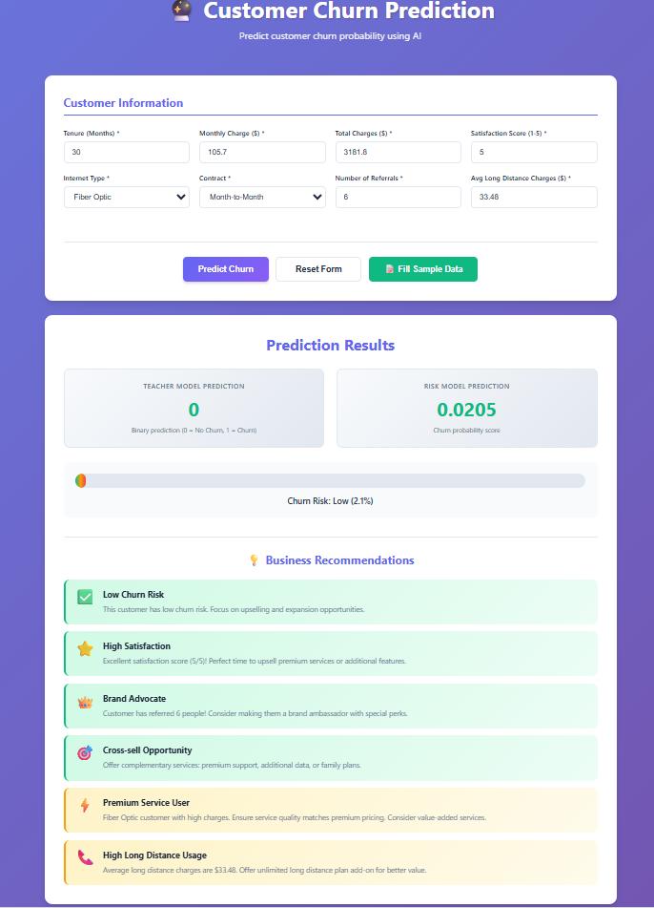
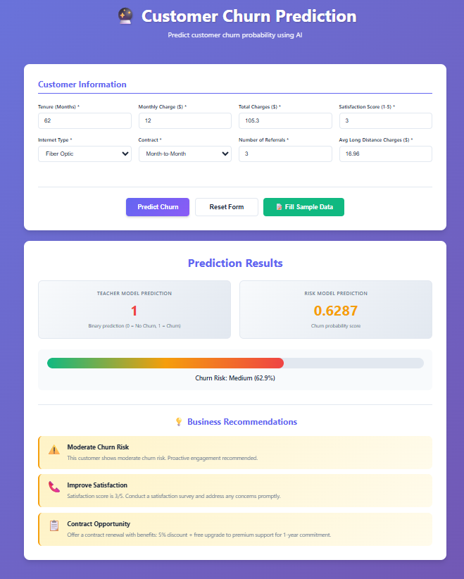

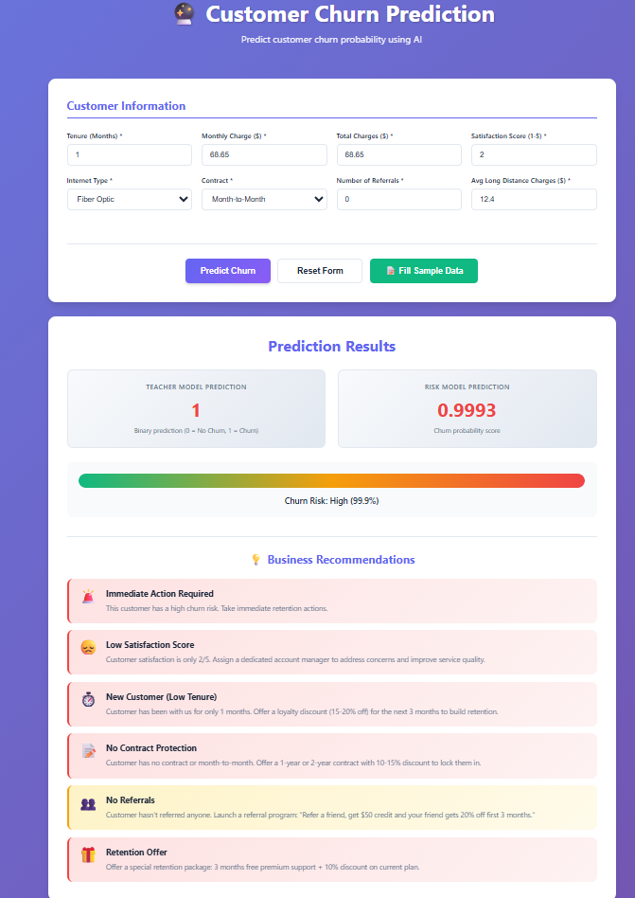
References:
1. Gallo, A. (2014). The value of keeping the right customers. Harvard Business Review.
https://hbr.org/2014/10/the-value-of-keeping-the-right-customers
2. Gupta, S., & Lehmann, D. R. (2003). Customers as assets. Journal of Interactive Marketing, 17(1), 9–24.
https://www.sciencedirect.com/science/article/pii/S1094996803701261
3. Verbeke, W., Martens, D., Mues, C., & Baesens, B. (2012). Building predictive models for customer churn in telecommunications. Expert Systems with Applications, 38(10), 263–272.
https://www.sciencedirect.com/science/article/abs/pii/S0957417410008067
4. Chang, V., Hall, K., Xu, Q. A., Amao, F. O., Ganatra, M. A., & Benson, V. (2024). Prediction of customer churn behavior in the telecommunication industry using machine learning models. Algorithms, 17(6), 231.
https://www.mdpi.com/1999-4893/17/6/231
5. Min, S., Zhang, X., Kim, N., & Srivastava, R. K. (2016). Customer acquisition and retention spending: An analytical model and empirical investigation in wireless telecommunications markets. Journal of Marketing Research, 53(5), 728–749.
https://doi.org/10.1509/jmr.14.0170
6.Wagh, S. K., Andhale, A. A., Wagh, K. S., Pansare, J. R., Ambadekar, S. P., & Gawande, S. H. (2024).
Customer churn prediction in telecom sector using machine learning techniques.
Results in Control and Optimization, 14, 100342.
https://doi.org/10.1016/j.rico.2023.100342
7.Saleh, S., & Saha, S. (2023).
Customer retention and churn prediction in the telecommunication industry: A case study on a Danish university.
SN Applied Sciences, 5(7).
https://doi.org/10.1007/s42452-023-05389-6
8.Omari, A., Al-Omari, O., Al-Omari, T., & Fati, S. M. (2025).
A predictive analytics approach to improve telecom’s customer retention.
Frontiers in Artificial Intelligence.
https://doi.org/10.3389/frai.2025.1600357
9.Optimove (2023).
Customer Acquisition vs. Retention Costs.
https://www.optimove.com/resources/learning-center/customer-acquisition-vs-retention-costs
10. Capella Solutions. (2024). Building vs Buying AI Solutions: A Decision Framework for Enterprise Leaders. Retrieved from https://www.capellasolutions.com/blog/building-vs-buying-ai-solutions-a-decision-framework-for-enterprise-leaders
11. Ascarza, E., Neslin, S. A., Netzer, O., Lemmens, A., Anderson, Z., Fader, P. S., … & Provost, F. (2018). In pursuit of enhanced customer retention management: Review, key issues, and future directions. Customer Needs and Solutions, 5(1-2), 65–81. https://doi.org/10.1007/s40547-017-0080-0

